**Project Title: Covid-19 using Cognos**

**PHASE 4: DEVELOPMENT PART 2**

**INTRODUCTION:**

The project involves analyzing COVID-19 cases and deaths data using IBM Cognos. The objective is to compare and contrast the mean values and standard deviations of cases and associated deaths per day and by country in the EU/EEA. This project encompasses defining analysis objectives, collecting COVID-19 data, designing relevant visualizations in IBM Cognos, and deriving insights from the data.

**Data Collection and Preprocessing**

* Collect Covid -19 data which include date, month, year, cases, death, countries and territories and any other relevant data.
* Preprocesses the data by handling missing values, encoding categorical Variable, scaling numerical features.
* Split the data into training and testing sets.
* **Importing Libraries**

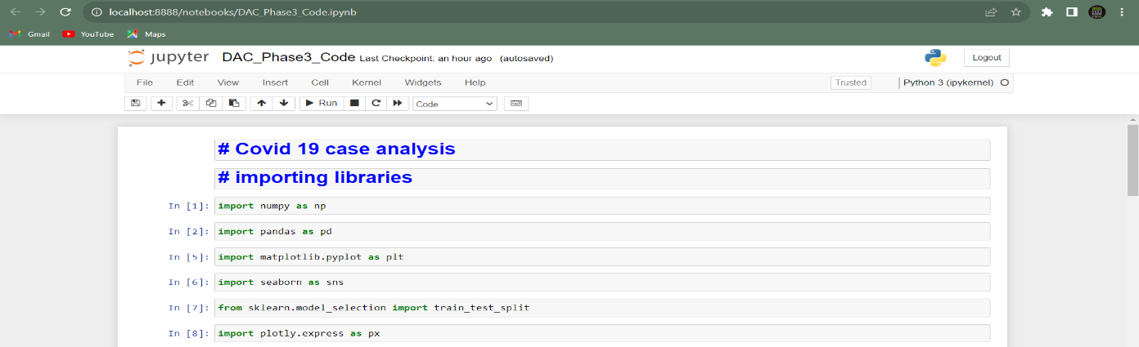

* **Importing COVID-19 Case Dataset**

**Dataset - https://www.kaggle.com/datasets/chakradharmattapalli/covid-19-cases**

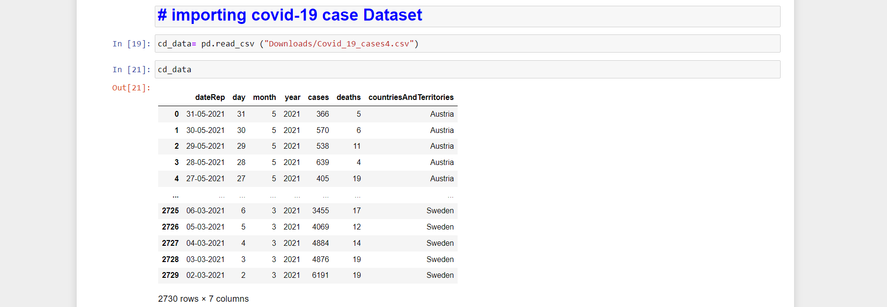

**Data Preprocessing**

* **Head, Tail and Shape of the data**

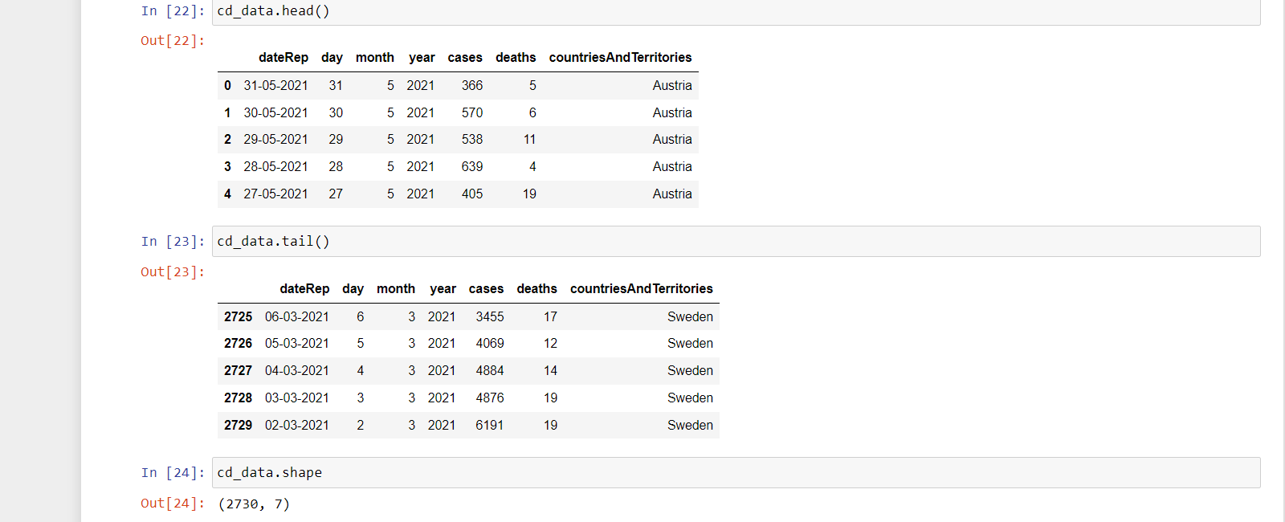

* **Describe and Information of the data**

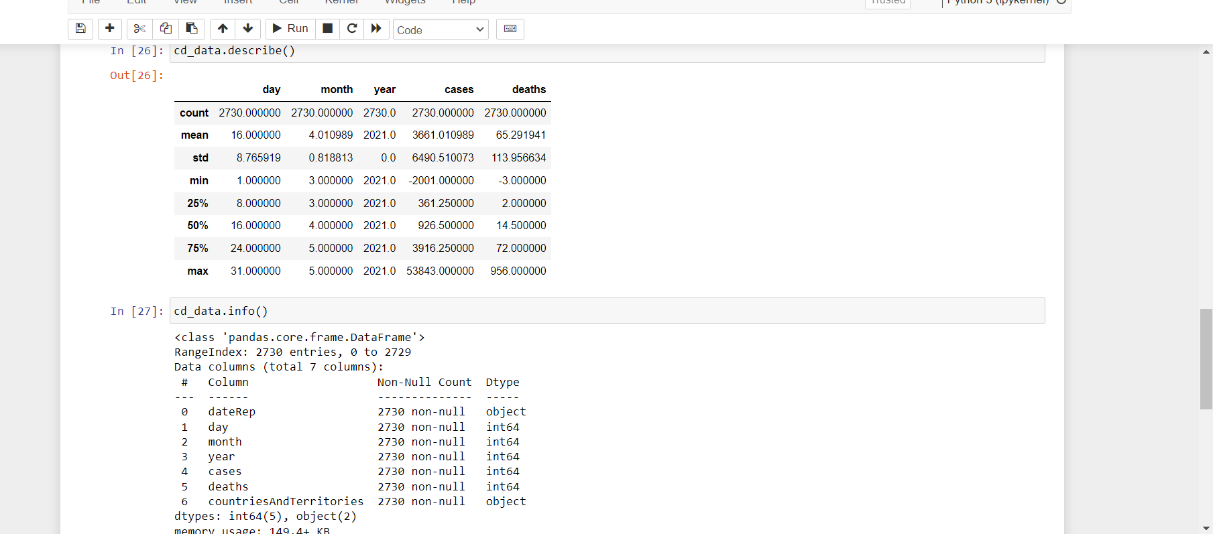

* **Null Values and Duplicates**

The dataset does not contain duplicates and missing values.

The data are split into **train and test dataset** for further development.

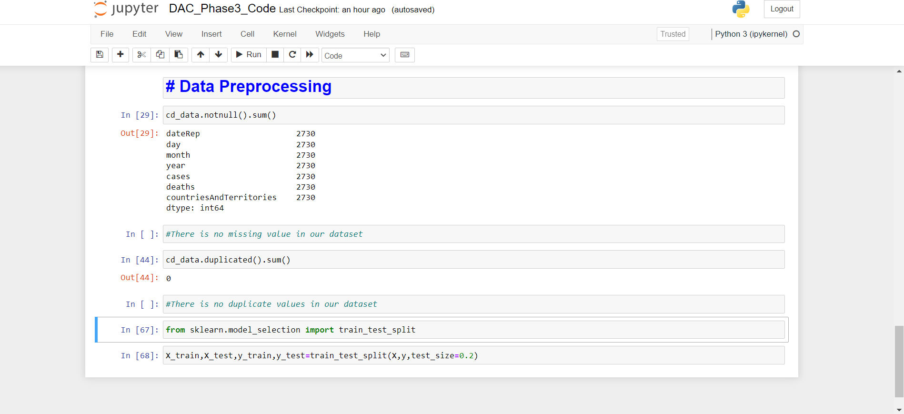

* **Data Visualization**

Creating a data visualization for covid-19 case analysis typically involves plotting various aspects of the data to provide insights into the spread of the virus.

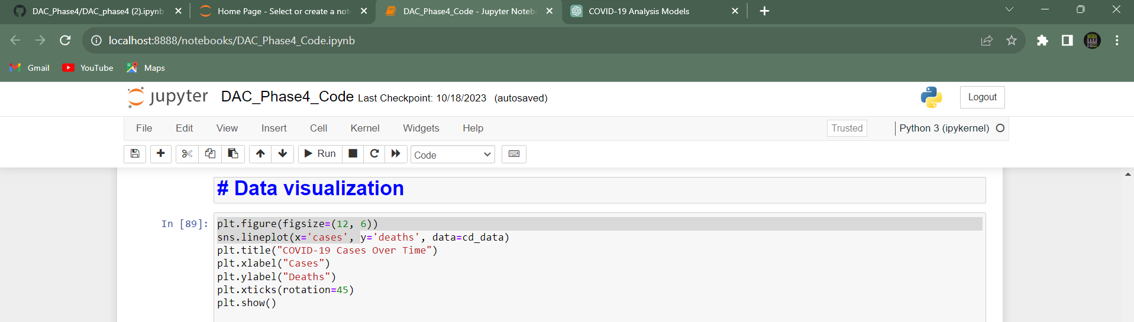

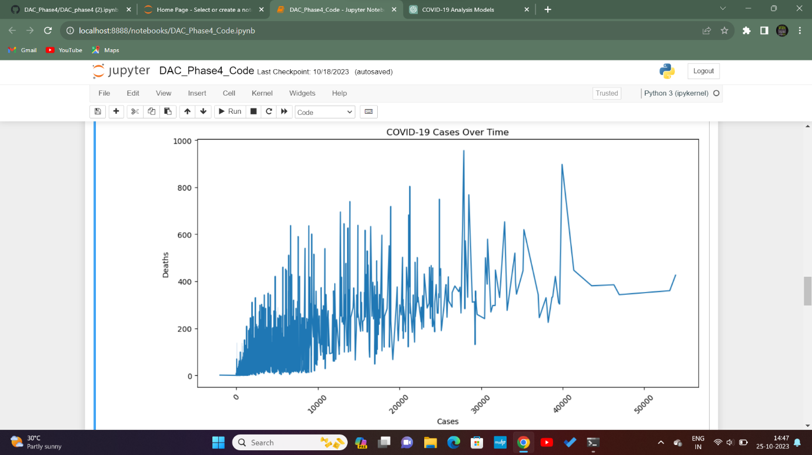

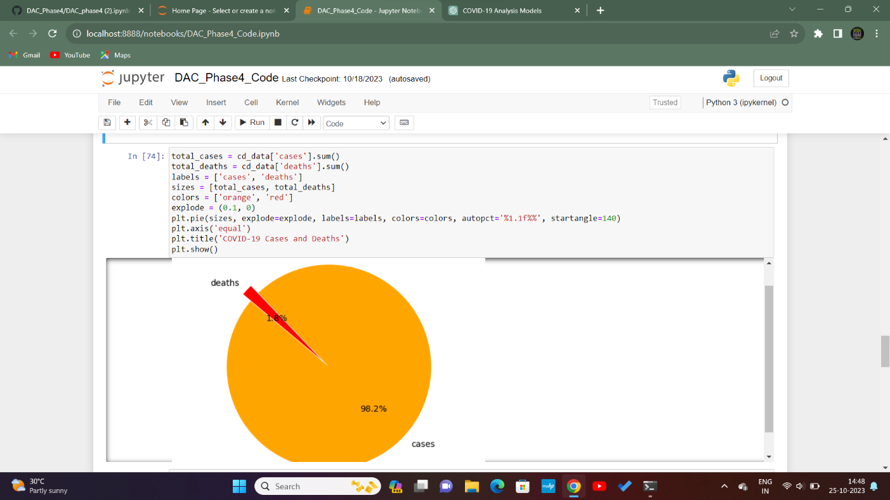

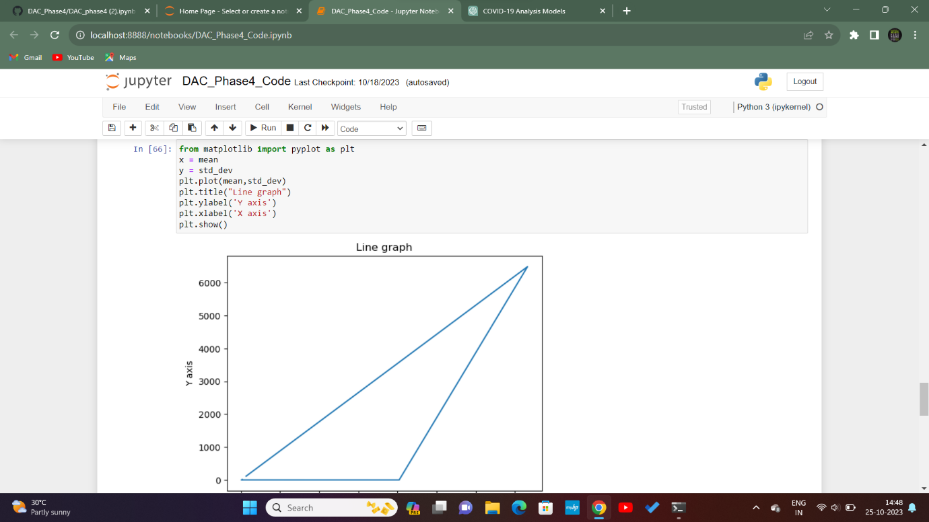

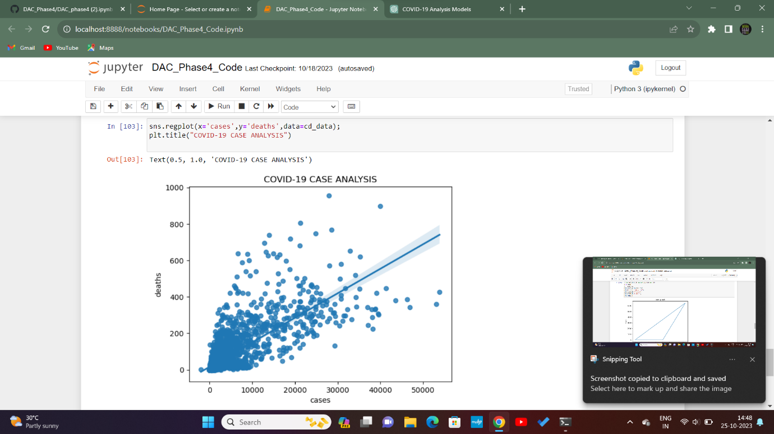

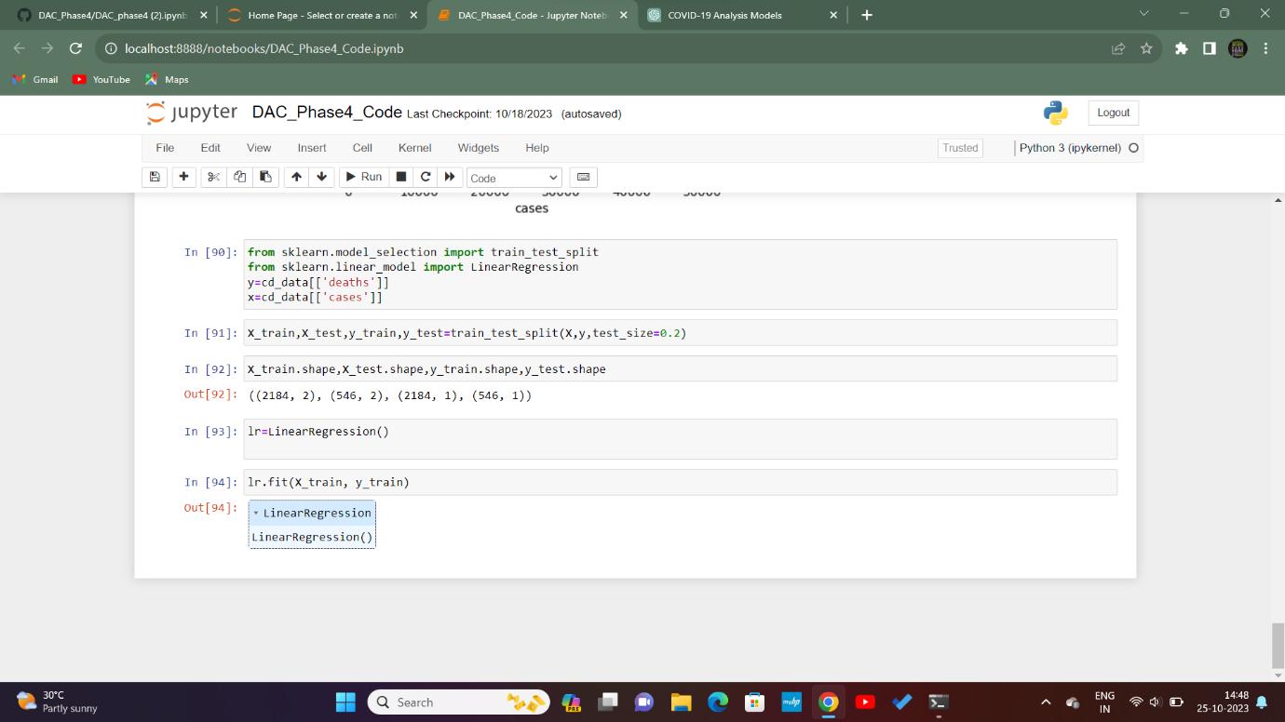

**CONCLUSION:**

Covid-19 Case analysis insights aid decision-makers in understanding current scenarios of, predicting future trends, and making informed choices. These insights guide healthcare professionals in allocating resources, implementing containment strategies, and adjusting public health measures to manage and migrate the impact of Covid-19 effectively.